Important Dates

Jan. 14 Incoming 6th Grade Parent Orientation Night 6:30 p.m. ~ Cafeteria
Jan 15 PTA Spirit Day Ledo Pizza in Columbia
Jan. 20 Schools/offices closed: MLK, Jr. Day
Jan. 24 End of 2nd Quarter
Jan. 27 Schools closed for students ~ Professional Work Day
Jan. 28-29 Smiles Dental 7:45 a.m. ~ Cafeteria
Jan. 29 Celebration of Unity and Colloborative Conversation 6:30 p.m. ~
Cafeteria
Jan. 30 Music Department Coffee House 7:00 p.m. Cafeteria

Feb. 1 HCPSS Solo & Ensemble Festival 9:00 a.m. L.R.H.S
Feb 3 2nd Quarter Report Cards issued
Feb. 4 Special Primary Election ~ Schools & offices closed
Feb. 5 It Takes a Village Day 7:00 a.m. Bulldog Den
Feb. 7 PVMS Talent Show 7:00 p.m. ~ Cafeteria
Feb. 17 Presidents’ Day ~ Schools & offices closed

***NEW ADDITIONS TO THE CALENDAR

NEW INFORMATION FROM PVMS
1/10/2020
PVMS Music Booster Coffeehouse
Join us for our first coffeehouse fundraiser and listen to our talented music students, while warming up with some coffee/hot chocolate and treats. There will also be a raffle for some wonderful baskets including Family Movie Night, Family Game Night & Parent’s Night In themes plus many more. Concessions will also be sold throughout the evening.
When: January 30th from 7-9pm
Where: Patuxent Valley Middle School 9151 Vollmerhausen Road Savage, MD 20763
Cost: $10 per person presale -includes admission and two concession items
(Children 11 & under are free, but does not include concession items)
$15 per person at the door
Order your tickets in advance online at https://checkout.square.site/buy/IKULQMAATWIRZVBQCKUYVFZM or send in a check made out to PVMS in an envelope marked coffeehouse to the front office, please include the number or tickets and your name and contact info. All tickets can be picked up at the event.
Childcare will be provided. All children must be potty trained. If you wish to have childcare, please RSVP to Amanda Fields at pvmsboosters@gmail.com
Here are blurbs for the PTA section:

SCHOOLHOUSE THEATER
Schoolhouse Theater is coming to PVMS and they are looking for interested students to be in the musical Aladdin. For grades 6-8, with rehearsals on Monday's from 6-8:30pm staring February 3 with the final show on April 1st & 2nd.
The cost is $175. $30 discount offered to the first 25 registrants. Turn in the form with payment to your student's homeroom teacher or drop off at the front office in an envelope labeled schoolhouse theater. Make check payable to Schoolhouse Theater.
Form and payment are the only ways to guarantee a discounted spot.
See our website (http://pvmspta.weebly.com/school-house-theater.html) or the flyer for more details. Email Archana Neidermeyer for any addition questions at archneid@gmail.com

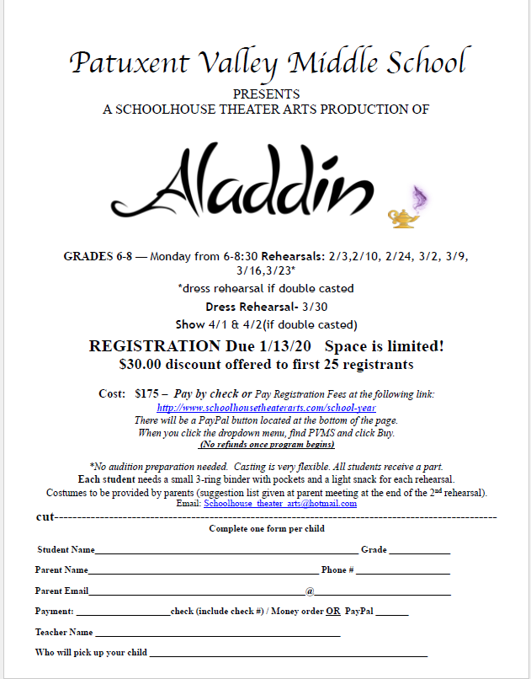

RESTAURANT SPIRIT DAY
Join us for our next Restaurant Spirit Day on Wednesday January 15 at Ledo Pizza at 6955 Oakland Mills Rd in Columbia from 11am to 10pm. A portion of the sales will go to the PTA to help fund events at PVMS. Just need to mention PVMS when ordering for us to get credit or show them the flyer. For a copy of the flyer, see attached or visit our website at http://pvmspta.weebly.com/pta-events.html
You can Dine in or Carry out. Visit their website at https://locations.ledopizza.com/ll/US/MD/Columbia/6955-Oakland-Mills-Rd or call them at 410-381-5550. Hope to see you there!! Go Bulldogs!!
From the Health Room:
LAST CALL FOR DENTAL PERMISSION FORMS! Patuxent Valley will by having a dental clinic on 1/28/20. Permission forms were sent home on 12/2/19. Dental disease results in 51 million lost school hours every year! Help your child get the dental care they need in order to keep them healthy and in the classroom. A Maryland licensed dentist will check your child’s mouth and teeth as well as provide a cleaning and x-rays as needed. They will also provide a fluoride treatment and apply sealants as needed. Please complete the permission form and return to the health room by 1/17/2020. Make sure to complete all sections (including the dental insurance portion). If your child does not have dental insurance and you would like help with the cost, please let the health room know so we can provide you a confidential donated care application.

BLACK STUDENT ACHIEVEMENT PROGRAM
SATURDAY MATH ACADEMY SPRING 2020 SESSION
Dates: Saturdays, February 1-March 14 (No class Feb 15)
Time: 9am-Noon
Location: Oakland Mills Highschool-9410 Kilimanjaro Road Columbia, Md. 21045
Fee: $80 (non refundable).
Who: All Howard county students Grades 3-12 Saturday
Purpose: Certified teachers offer instruction and enrichment in all levels of mathematics to a diverse student population. Students will have opportunities to engage in STEM related activities or chess instruction.
Registration is required!
Registration Day: Saturday January 18, 2020 (Online or Walk-in until capacity is reached)
Online Registration via HCPSS Connect
Walk-in Registration details: Must have HCPSS Connect login prior to registration
Walk In location: Oakland Mills High School (see address above)
Time: 9 a.m.–Noon until capacity is reached
Walk In payment options: Cash, Check, Money Order
Checks or money orders make payable to: HCPSS – BSAP Saturday Math Academy
If you have additional questions, contact Patricia Andrews at Patricia_Andrews@hcpss.org or 410-313-1598 or visit www.hcpss.org/schools/bsap/saturday-math-academy/

FREE EYE EXAMS AND GLASSES to HCPSS students that need them
"We have an exciting clinic which will take place at Howard High School​ coming up at the end of February and the beginning of March that will provide FREE EYE EXAMS AND GLASSES to HCPSS students that need them. There is an extensive email below with all the details. Please feel free to pass this information along to families or students that might need this free service especially those students that might not have vision insurance. The attachments are also helpful in passing along information. The WORD document needs to be filled out in order to make the appointment. The COMPLETED forms can be brought to the health room and it will get passed along to health services."

Eye Exam Reservation Form
Free services and glasses will be provided regardless of insurance or citizen status. Please complete form to obtain service. All information provided will remain confidential and will only be used for the SOLE purpose of services delivered as part of the Beyond 2020 outreach program.

Student Information
Name: ________________________________, ____________________________ (Last, First)
School: ________________________________ Grade: _________ Homeroom Teacher: _____________________
Parent/Guardian Information
Name: ________________________________, ____________________________ (Last, First)
Phone: (_____) ______-_____________ Email (optional):_____________________________________________

Preferred Eye Exam Times (date and time)
Saturday Feb 29 AM 8:30 9:30 10:30 PM 12:30 1:30 2:30
Sunday March 1 AM 8:30 9:30 10:30 PM 12:30 1:30 2:30

1st Choice: ____________________ 2nd Choice: ____________________ 3rd Choice: ____________________

Background Information
Does your child wear glasses? Yes or No
If yes, please bring most current pair of glasses and/or prescription
Has your child experienced any reading difficulties? Yes or No
Within the last twelve months, has your child received a comprehensive eye exam from an eye doctor
(optometrist or ophthalmologist)? Yes or No
Do you require an interpreter? Yes or No
If yes, which language? ___________________________________
Do you require transportation assistance? Yes or No

BELOW IS INFORMATION FROM PREVIOUS GAZETTES

Attention Step team parents!
Step team t-shirts are available for purchase. Team members will receive 2 shirts as a part of their uniform for the cost of $22.
We will begin wearing uniforms for our first outside performance on 1/15/20 at Hammond High school.
T-shirt payments can be made to Ms. Thompson or Ms. Galloway via cash, money order, check payable to PVMS memo: Step team t-shirts, or online using the following payment link:
https://osp.osmsinc.com/HowardMD/BVModules/CategoryTemplates/Detailed%20List%20with%20Properties/Category.aspx?categoryid=DA047
Patuxent Valley Middle - Online School Payments
Online School Payments (OSP) portal is a service provided to parents to facilitate payment for school fees for a variety of products and services.
osp.osmsinc.com
If financial assistance is needed regarding t-shirt purchases please contact Ms. Thompson (Anisha_Thompson@hcpss.org) or Ms. Galloway (Leirdre_Galloway@hcpss.org) as assistance is available.

Calling All Student Creative Writers and Photographers:
The Howard County Middle School Creative Works Magazine, Our Voice, is published annually as a showcase of student writing and photography. The editors are currently seeking submissions. If you have an original short story, poem, review, essay, journalistic writing or other creative composition that you would like to submit, please have your child see Monica Chelidona, the GT Resource Teacher, or their English teacher for an entry form and guidelines. In addition, Our Voice accepts photographic entries. If your child has taken creative and artistic photograph, then see the GT Resource Teacher to enter it for publication. All submissions are due January 31, 2020. Let your child’s imagination and creativity take hold and submit your original work to Our Voice!

PVMS has a School Based Wellness Center!
Be sure to complete the forms for your child - forms available in the health room or on the PVMS website at this link: http://pvms.hcpss.org/sites/default/files/English-%20School-Based%20Wellness%20Center%20Enrollment%20Packet_0.pdf
School-based wellness centers help students stay in school or get back to school quicker. This service also helps parents miss less days at work. There is NO copay or fees for visits to the Wellness Center. The nurse practitioner provides assessment, diagnosis and treatment of acute illnesses such as strep throat, impetigo and ear infections. Some students can also be seen at the Wellness Center for physicals, medication orders, immunizations, health education and sports physicals. Parents communicate by phone or can come to the wellness center for the visit. This health care option is available for all students at PVMS and BBES. Complete and return the forms today!

Raising the Flag
Is your student currently a Girl Scout, Boy Scout, or Cadet?
We have an opportunity for them to honor our local Veterans!
PVMS would like all Scouts to sign-up for “Raising the Colors”.
We will schedule Scouts twice a month to perform this duty.
For more information and to sign-up all Scouts see Mrs. Minnick in the front office.

PTA NEWS
Keep those membership forms and donations coming in! You can send them in with your student. Forms can be found on our website.
Also keep filling out the survey to let us know what you would like us to do for you. https://www.surveymonkey.com/r/X5SZLFZ
To keep up to date with PTA news please visit our website often at www.pvmspta.weebly.com
Also follow us on Facebook at www.facebook.com/pvmspta
Or contact us with any questions at pvmsptamd@gmail.com
Thank you!

Family File Emergency Information
Dear PVMS Parents/Guardians,
Every year, HCPSS requires that all parents/guardians complete the Family File Emergency Information for each student. Without this updated information, your student risks the possibility of not being able to attend field trips or participate in after school activities. Safety is a primary consideration for all of our students, and updated Emergency Contact Information plays an important part.
Go to www.hcpss.org select HCPSS CONNECT, select HCPSS Connect Login, type your user name (parent email) and password. Once logged in go to the Family File tab and follow the steps
to verify and/or update. Forgot password? See information link located on HCPSS Connect
Login page. PLEASE UPDATE FAMILY FILE INFORMATION AS SOON AS POSSIBLE
Contact Mrs. Minnick or Mrs. Andersen with any questions or concerns at 410-880-5840.

School Messenger Text Alerts
Due to the number of late buses and bus changes this year, it has been requested that we send out directions on how parents/guardians can sign up their student to receive text alerts via School Messenger. The directions are included below.

Step 1: go to https://www.hcpss.org/hcpss
Step 2: go to Sign-up (Non-HCPSS Parents/Guardians)
Step 3: Complete Subscriber Information
Step 4: Using your cell phone text the word YES to the number 67587 to activate your subscription after signing up. Students will automatically receive HoCo Weather Alert.
Note: You may deactivate your subscription by texting the work STOP to the number 67587.

