Important Dates
Nov. 25-26 Schools close 3 hrs. early ~ Parent/Teacher Conferences
Nov. 27 Schools closed for students ~ Parent/Teacher Conferences
Nov. 28-29 Schools/Offices closed ~ Thanksgiving Holiday

Dec. 3 Winter Orchestra Concert 7:00 p.m. ~ Hammond H.S.
Dec. 4 Holiday Bazaar 5:00 p.m. ~ Cafeteria
Dec. 12 Winter Band Concert 7:00 p.m. ~ Hammond H.S.
Dec. 17 Winter Choral Concert 7:00 p.m. ~ Cafeteria
Dec. 23-Jan1 Schools Closed ~ Winter Break

Jan. 2 Schools re-opened
Jan. 9 Booster Meeting/PTA 6:00 p.m ~ Booster Meeting
7:00 p.m ~ PTA Meeting
Jan. 20 Schools/offices closed: MLK, Jr. Day
Jan. 24 End of 2nd Quarter
Jan. 27 Schools closed for students ~ Professional Work Day
Jan. 28-29 Smiles Dental 7:45 a.m. ~ Cafeteria

***NEW ADDITIONS TO THE CALENDAR

NEW INFORMATION FROM PVMS
11/22/2019
Lost and Found Items
Items from our Lost and Found will be displayed at the Welome Table during the Parent/Tteacher Conferences. Please stop by for your missing items.

Orchestra Winter Concert
The Orchestra Winter Concert is Tuesday, December 3, 2019 at Hammond HS. Concert begins at 7:00pm! Hope to see you there!

Teacher Conference Dinner
The PVMS PTA will host the Teacher Conference Dinner on Tuesday, November 26 from 4:30p to 6:30pm to show our appreciation to the teachers and staff. We ask you to consider donating food items for this special dinner. All foods should be brought to the school no later than 4:00pm ready to serve. If you are short on time to shop & cook or cooking just isn’t your thing, cash donations to the PVMS PTA are welcome to help prepare this meal.
Please go to sign-up https://www.signupgenius.com/go/4090A4FADAC2AA13-pvms2 to show your support!

PVMS has a School Based Wellness Center!
Be sure to complete the forms for your child - forms available in the health room or on the PVMS website at this link: http://pvms.hcpss.org/sites/default/files/English-%20School-Based%20Wellness%20Center%20Enrollment%20Packet_0.pdf
School-based wellness centers help students stay in school or get back to school quicker. This service also helps parents miss less days at work. There is NO copay or fees for visits to the Wellness Center. The nurse practitioner provides assessment, diagnosis and treatment of acute illnesses such as strep throat, impetigo and ear infections. Some students can also be seen at the Wellness Center for physicals, medication orders, immunizations, health education and sports physicals. Parents communicate by phone or can come to the wellness center for the visit. This health care option is available for all students at PVMS and BBES. Complete and return the forms today!

BELOW IS INFORMATION FROM PREVIOUS GAZETTES

PVMS Music Department
The PVMS Music Department is selling World's Finest Chocolates from 11/4/19 to 12/2/19! Please consider selling for $1.00 each bar OR $60.00 for a case! We get 50% back on all profits! Thank you!

The PVMS Steppers ask YOU to SAVE THE DATE
December 4th, 2019 4:30pm-8:00pm
Just in time for your Holiday Shopping!
Come to the 2nd Annual Holiday Bazaar
Spend a little SUPPORT a Lot!!
PVMS School Cafeteria
Local Vendors for shopping, special treats for eating,
Performances by our PVMS students.
Fundraising for our school uniform and traveling expenses.

Raising the Flag
Is your student currently a Girl Scout, Boy Scout, or Cadet?
We have an opportunity for them to honor our local Veterans!
PVMS would like all Scouts to sign-up for “Raising the Colors”.
We will schedule Scouts twice a month to perform this duty.
For more information and to sign-up all Scouts see Mrs. Minnick in the front office.

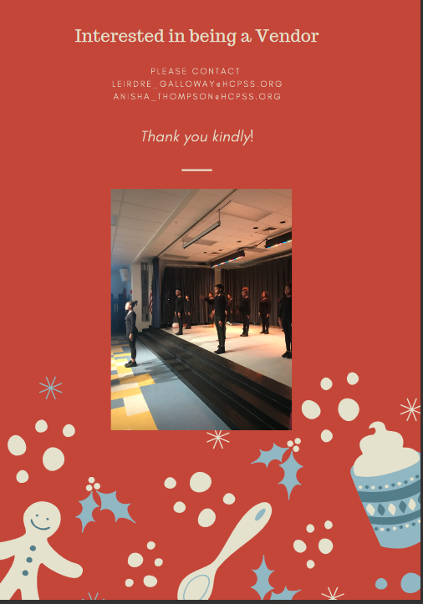
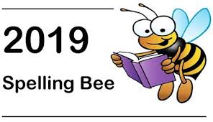

Thursday
December 5th, 2019
7:50 a.m.

Please see
Mr. Schemm
or
Ms. Smith
for a packet

PTA NEWS
Keep those membership forms and donations coming in! You can send them in with your student. Forms can be found on our website.
Also keep filling out the survey to let us know what you would like us to do for you. https://www.surveymonkey.com/r/X5SZLFZ
To keep up to date with PTA news please visit our website often at www.pvmspta.weebly.com
Also follow us on Facebook at www.facebook.com/pvmspta
Or contact us with any questions at pvmsptamd@gmail.com
Thank you!

Family File Emergency Information
Dear PVMS Parents/Guardians,
Every year, HCPSS requires that all parents/guardians complete the Family File Emergency Information for each student. Without this updated information, your student risks the possibility of not being able to attend field trips or participate in after school activities. Safety is a primary consideration for all of our students, and updated Emergency Contact Information plays an important part.
Go to www.hcpss.org select HCPSS CONNECT, select HCPSS Connect Login, type your user name (parent email) and password. Once logged in go to the Family File tab and follow the steps
to verify and/or update. Forgot password? See information link located on HCPSS Connect
Login page. PLEASE UPDATE FAMILY FILE INFORMATION AS SOON AS POSSIBLE
Contact Mrs. Minnick or Mrs. Andersen with any questions or concerns at 410-880-5840.

School Messenger Text Alerts
Due to the number of late buses and bus changes this year, it has been requested that we send out directions on how parents/guardians can sign up their student to receive text alerts via School Messenger. The directions are included below.

Step 1: go to https://www.hcpss.org/hcpss
Step 2: go to Sign-up (Non-HCPSS Parents/Guardians)
Step 3: Complete Subscriber Information
Step 4: Using your cell phone text the word YES to the number 67587 to activate your subscription after signing up. Students will automatically receive HoCo Weather Alert.
Note: You may deactivate your subscription by texting the work STOP to the number 67587.

