Important Dates

Dec. 11 Booster Meeting/PTA 6:00 p.m ~ Booster Meeting
7:00 p.m ~ PTA Meeting
Dec. 12 Winter Band Concert 7:00 p.m. ~ Hammond H.S.
Dec. 17 Winter Choral Concert 7:00 p.m. ~ Cafeteria
Dec. 23-Jan1 Schools Closed ~ Winter Break

Jan. 2 Schools re-opened
Jan. 9 Booster Meeting/PTA 6:00 p.m ~ Booster Meeting
7:00 p.m ~ PTA Meeting
Jan. 20 Schools/offices closed: MLK, Jr. Day
Jan. 24 End of 2nd Quarter
Jan. 27 Schools closed for students ~ Professional Work Day
Jan. 28-29 Smiles Dental 7:45 a.m. ~ Cafeteria

***NEW ADDITIONS TO THE CALENDAR

NEW INFORMATION FROM PVMS
12/6/2019

Hammond High's Scheduling/Information Night
Hammond High's Scheduling/Information Night will be on January 8, from 6 to 8 pm at Hammond. Just a FYI! Students and parents are welcome, we will start in Auditorium with a presentation, then students and parents can meet with teachers and get more information on classes.

Calling All Student Creative Writers and Photographers:
The Howard County Middle School Creative Works Magazine, Our Voice, is published annually as a showcase of student writing and photography. The editors are currently seeking submissions. If you have an original short story, poem, review, essay, journalistic writing or other creative composition that you would like to submit, please have your child see Monica Chelidona, the GT Resource Teacher, or their English teacher for an entry form and guidelines. In addition, Our Voice accepts photographic entries. If your child has taken creative and artistic photograph, then see the GT Resource Teacher to enter it for publication. All submissions are due January 31, 2020. Let your child’s imagination and creativity take hold and submit your original work to Our Voice!

From the Health Room:
Patuxent Valley will by having a dental clinic on 1/28/20. Permission forms were sent home on 12/2/19. Dental disease results in 51 million lost school hours every year! Help your child get the dental care they need in order to keep them healthy and in the classroom. A Maryland licensed dentist will check your child’s mouth and teeth as well as provide a cleaning and x-rays as needed. They will also provide a fluoride treatment and apply sealants as needed. Please complete the permission form and return to the health room by 12/20/19. Make sure to complete all sections (including the dental insurance portion). If your child does not have dental insurance and you would like help with the cost, please let the health room know so we can provide you a confidential donated care application.

PVMS talent show auditions
Wednesday December 11th during 8th period
Students interested please sign up with Ms. Francis or Ms. Thompson

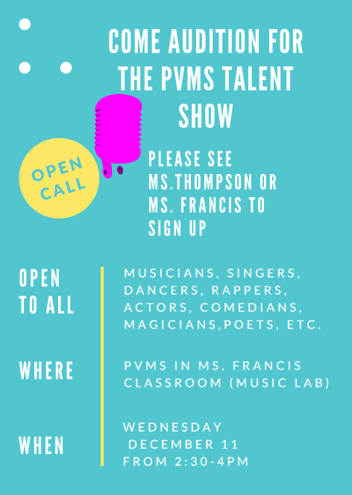

BELOW IS INFORMATION FROM PREVIOUS GAZETTES

PVMS has a School Based Wellness Center!
Be sure to complete the forms for your child - forms available in the health room or on the PVMS website at this link: http://pvms.hcpss.org/sites/default/files/English-%20School-Based%20Wellness%20Center%20Enrollment%20Packet_0.pdf
School-based wellness centers help students stay in school or get back to school quicker. This service also helps parents miss less days at work. There is NO copay or fees for visits to the Wellness Center. The nurse practitioner provides assessment, diagnosis and treatment of acute illnesses such as strep throat, impetigo and ear infections. Some students can also be seen at the Wellness Center for physicals, medication orders, immunizations, health education and sports physicals. Parents communicate by phone or can come to the wellness center for the visit. This health care option is available for all students at PVMS and BBES. Complete and return the forms today!

Raising the Flag
Is your student currently a Girl Scout, Boy Scout, or Cadet?
We have an opportunity for them to honor our local Veterans!
PVMS would like all Scouts to sign-up for “Raising the Colors”.
We will schedule Scouts twice a month to perform this duty.
For more information and to sign-up all Scouts see Mrs. Minnick in the front office.

PTA NEWS
Keep those membership forms and donations coming in! You can send them in with your student. Forms can be found on our website.
Also keep filling out the survey to let us know what you would like us to do for you. https://www.surveymonkey.com/r/X5SZLFZ
To keep up to date with PTA news please visit our website often at www.pvmspta.weebly.com
Also follow us on Facebook at www.facebook.com/pvmspta
Or contact us with any questions at pvmsptamd@gmail.com
Thank you!

Family File Emergency Information
Dear PVMS Parents/Guardians,
Every year, HCPSS requires that all parents/guardians complete the Family File Emergency Information for each student. Without this updated information, your student risks the possibility of not being able to attend field trips or participate in after school activities. Safety is a primary consideration for all of our students, and updated Emergency Contact Information plays an important part.
Go to www.hcpss.org select HCPSS CONNECT, select HCPSS Connect Login, type your user name (parent email) and password. Once logged in go to the Family File tab and follow the steps
to verify and/or update. Forgot password? See information link located on HCPSS Connect
Login page. PLEASE UPDATE FAMILY FILE INFORMATION AS SOON AS POSSIBLE
Contact Mrs. Minnick or Mrs. Andersen with any questions or concerns at 410-880-5840.

School Messenger Text Alerts
Due to the number of late buses and bus changes this year, it has been requested that we send out directions on how parents/guardians can sign up their student to receive text alerts via School Messenger. The directions are included below.

Step 1: go to https://www.hcpss.org/hcpss
Step 2: go to Sign-up (Non-HCPSS Parents/Guardians)
Step 3: Complete Subscriber Information
Step 4: Using your cell phone text the word YES to the number 67587 to activate your subscription after signing up. Students will automatically receive HoCo Weather Alert.
Note: You may deactivate your subscription by texting the work STOP to the number 67587.

