Important Dates

June 7 8th Grade Dance 6:30 p.m. ~ Cafeteria
June 11 Band playing National Anthem at Baysox Game 4:30 p.m. ~ Bowie
Baysox Game
June 13 8th Grade to Six Flags 9:30 a.m. ~ Six Flags
June 18 8th Grade Promotion Ceremony 6:00 p.m. ~ Hammond H.S.
June 19 3 hour early dismissal
June 20 2nd to last day of school – 3 hour early dismissal
June 21 Last day of school – 3 hour early dismissal

***NEW ADDITIONS TO THE CALENDAR

NEW INFORMATION FROM PVMS
6/7/2019

ATTENTION: PARENTS OF STUDENTS WHO HAVE MEDICATION IN THE HEALTH ROOM.
IF YOUR CHILD HAS MEDICATION IN THE HEALTH ROOM, ALL MEDICATION MUST BE PICKED UP BY 11:30 A.M. ON 6/21/19. ONLY CHILDREN WHO HAVE BEEN APPROVED BY THEIR DOCTOR TO SELF- CARRY INHALERS AND EPI-PENS ARE PERMITTED TO CARRY MEDICATION TO AND FROM SCHOOL. ALL OTHER MEDICATIONS, MUST BE PICKED UP BY AN ADULT. ABSOLUTELY NO MEDICATION IN PILL FORM MAY BE CARRIED BY A STUDENT.
IF YOU HAVE ANY QUESTIONS, PLEASE CALL THE HEALTH ROOM ON 410-880-5880.

Our School Garden Needs Your Help!
Thank you so much to all the families that have sent in clamshell containers for the school garden. We have a full supply for this year's harvest, so no need to send in more. (But don't worry, we'll be asking again next year!)

We could still use some people to help maintain the garden over the summer. This would involve coming to water, weed, and harvest our fresh vegetables. Please contact Michelle Langan (michelle_langan@hcpss.org) or Rebecca Stryker (rebecca_stryker@hcpss.org) for more information.

BELOW IS INFORMATION FROM PREVIOUS GAZETTES

Howard County Public School System
MIDDLE SCHOOL STUDENT SUPPLY MENU – 2019-2020

The number indicates the maximum that can be requested; each team will develop a supply list from the menu according
to school/interdisciplinary needs.
ITEM Grade 6 Grade 7 Grade 8

3-Ring Binder 1 1 1
AND up to 2
1”, 1.5” or 2” binders (poly or other) 9 9 9
OR if a school requires 9 smaller binders, students will not carry a large 3-ring binder.

Loose Leaf Paper constant supply constant supply constant supply
Dividers 4 8-pk 4 8-pk 4 8-pk
1-Subject Spiral Notebook 7 7 7
5-Subject Spiral Notebook 2 2 2
Marble Composition Books 4 4 4

Pocket Folders 9 9 9
Black or Blue Pens constant supply constant supply constant supply
#2 Pencils constant supply constant supply constant supply
Red Pen 1 per quarter 1 per quarter 1 per quarter
Highlighters 4 4 4
Zippered Pencil Pouch 1 1 1

Glue Stick constant supply constant supply constant supply
Ruler 1 1 1
Protractor 1 1 1
Compass 1 1 1
Scissors 1 1 1

Set of Colored Pencils 1 1 1
OR
Set of Colored Markers 1 1 1
OR
Set of Crayons 1 1 1

3 x 5 Index Cards – 100/pk 3 packs 3 packs 3 packs
3 x 3 Sticky Notes – 100/pk 1 pack 1 pack 1 pack
Paper reinforcements 1 pack 1 pack 1 pack

1 USB Flash Drive (file storage) 1 1 1

Parents: Throughout the year, your child’s teacher(s) will identify items for donation that will be appreciated. One such item is boxes of tissues for classroom use. If you would like to donate these, please send them in with your child. Thank you.
The TI-84 Plus Silver Edition Graphing Calculator will be used regularly in your child’s class. Graphing calculators are an important technology used in Howard County mathematics courses beginning with pre-algebra and extending through the end of the mathematics course sequence. Although students will be provided with a graphing calculator for use in school and have the ability to borrow one for out of school use, students are best served by having a personal calculator and becoming very familiar with how it is used to address a number of different types of mathematics problems. Students who go on to take mathematics courses in college will often be able to use the same calculator for college course work.

A Message from the Health Room - Spring Allergies!
SPRING ALLERGIES have started. Does your child suffer from spring allergies? The following are some things you can do to help your child during the allergy season:
1) Regularly give allergy medication as advised by your health care provider. Giving it in the morning prior to school will help alleviate symptoms during the school day.
2) When your child comes in from outdoors (including recess at school!), the following may help alleviate symptoms:
a) wash hands with soap and water,
b) wash off face, including glasses, with a wash cloth or splash water on face,
c) wipe down the front of the clothing with a wet paper towel or cloth
3) Try not to allow your child to go into the bedroom with clothing worn outside; this will prevent the pollen from getting in the bed linen.

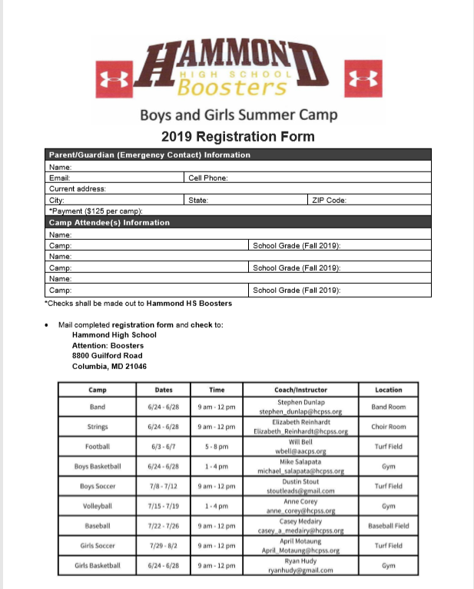

Rankers Sports camp
Looking for a fun and active camp this summer for your son and/or daughter? Come out to Reservoir High School for Rankers Sports camp with Howard County teachers/coaches Phil Ranker (phys ed), Erika Lupo (phys ed) and Tom Dougherty (math). We play many different sports throughout the week including: capture the football, soccer, basketball, volleyball, tseg ball, tag games, tennis, scooter games and many many more. If your child likes PE class, they will absolutely LOVE this camp. Dates for camp: July 1-5 (no camp on July 4-prorated cost) and July 15-19. Half day and full day options are available. Please email phillip_ranker@hcpss.org or visit www.rankerssportscamp.weebly.com for any questions.

ATTENTION: PARENTS OF 6TH GRADERS
**IMPORTANT INFORMATION FOR THE 2019-2020 SCHOOL YEAR REGARDING IMMUNIZATION REQUIREMENTS FOR 7TH GRADE

FROM THE HEALTH ROOM:
It’s time to start thinking about immunization requirements for next school year. All students who will be entering Grade 7 in the fall 2019 are required by the state of Maryland to have proof of 1 dose of the Tdap vaccine and 1 dose of the Meningococcal vaccine (MCV4) by the first day of the 2019-2020 school year. If we DO NOT receive proof of immunization, your child will be excluded from school on the first day. Many students may have already received these immunizations, but the Health Room may not have the updated immunization record. Please contact your child’s doctor and send/fax in an updated copy of your child’s immunizations to the Health Room. Our fax number is (301) 490-3780. Students receiving immunizations over the summer can either email the scanned copy to dee_goldstein@hcpss.org or drop the form off in the front office.
If you have further questions, please call PVMS on (410) 880-5880.

PVMS Marketplace
Marketplace is a space located within PVMS. This space was created to benefit any families within the school and our community. We have been able to assist families with food items, clothing, shoes, etc. Donations of new and gentley used items are accepted as well as much needed food items. We accept snack items, juice, water and all non-perishables items. Please no high sugar items such as soda or candy. For further information please feel free to contact Ms. Deb Costley at Debbie_Costley@hcpss.org or 410-880-5480.

Family File Emergency Information
Dear PVMS Parents/Guardians,
Every year, HCPSS requires that all parents/guardians complete the Family File Emergency Information for each student. Without this updated information, your student risks the possibility of not being able to attend field trips or participate in after school activities. Safety is a primary consideration for all of our students, and updated Emergency Contact Information plays an important part.
Go to www.hcpss.org select HCPSS CONNECT, select HCPSS Connect Login, type your user name (parent email) and password. Once logged in go to the Family File tab and follow the steps
to verify and/or update. Forgot password? See information link located on HCPSS Connect
Login page. PLEASE UPDATE FAMILY FILE INFORMATION AS SOON AS POSSIBLE
Contact Mrs. Minnick or Mrs. Andersen with any questions or concerns at 410-880-5840.

School Messenger Text Alerts:
Due to the number of late buses and bus changes this year, it has been requested that we send out directions on how parents/guardians can sign up their student to receive text alerts via School Messenger. The directions are included below.
Step 1: go to https://www.hcpss.org/hcpss
Step 2: go to Sign-up (Non-HCPSS Parents/Guardians)
Step 3: Complete Subscriber Information
Step 4: Using you cell phone text the word YES to the number 67587 to activate your subscription after signing up. Students will automatically receive HoCo Weather Alert.
Note: You may deactivate your subscription by texting the work STOP to the number 67587.

Ronald McDonald House
Dear PVMS Community, In the past 12 years, PVMS has been collecting pull-tabs the Ronald McDonald House (RMH) in Philadelphia. The RMH is a “home-away-home” where families can stay when their child has a severe or terminal illness and is at Children’s Hospital. The RMH only charges the entire family $15.00 a night and that includes a kitchen. For children who spend up to 9 months in the hospital, the RMH makes it possible for families to stay together.
The pull-tab as opposed to the can has a higher percentage of aluminum which makes it valuable for recycling. The RMH accepts pull-tabs. They are weighed and recycled them for a cash flow which helps to support their program.
Any pull-tabs are accepted, from soda, vegetable, soup, beans, dog and cat food, beer, energy drinks and even tennis ball cans! For every 10 pull-tabs your child will receive 1 bark buck. In previous years, students have collected pull-tabs from their parent’s work, churches, recreation center and more. Some students have brought in thousands of pull-tabs.
My first year at PVMS we collected 500 lbs. of pull-tabs for the RMH. THIS PAID THEIR UTILITIES FOR A FULL YEAR! If anyone would like a labeled collection jar please contact me and I will get one to you ASAP.Sincerely, Bonnie L. Taylor Health Educator

