January 5, 2018

Calling all creative student writers and photographers!
PVMS is currently accepting original poetry, fiction, non-fiction and photography to be showcased in the annual county publication, Our Voice. Submissions are open to all current 6th, 7th, and 8th grade students attending Howard County Middle Schools. Literary entries will be evaluated based on originality, creative use of language, and distinctive voice. Photography entries will be evaluated on composition, use of photographic techniques, and originality. Selected writing and photographs will be published in the 2018 edition of Our Voice.
Students should see Ms. Bickerton or their ELA teacher for the guidelines and cover sheet. Entries are due February 2, 2018.

Students in 7th and 8th grade GT social studies:
Ms. Bickerton is hosting “8th period” after school help/ work sessions for National History Day Thursdays from January 11th- February 1st. Interested students should pick up a permission form in the cafeteria this week. The first 24 students to return permission forms will be allowed to attend. Students will be notified by January 9th if they have a spot. Students will be able to use the after school activities bus if needed.

Music Department Notes
Dear PVMS Music Department Parents,
As we prepare for upcoming Spring competition /trip to Kings Dominion on May 11, 2018, we need for all band / choir/ orchestra parents to complete the Music Department Spring Trip Interest Form. This form can be completed online, and the link is listed below. * Please note, only complete one form per child. If you have a child in band and another child in orchestra, you would need to complete 2 online forms. Thanks so much for your time.

PVMS MUSIC TRIP INTEREST FORM - https://docs.google.com/forms/d/e/1FAIpQLSffmKpvf2OYOk-5-lgVy6CVB9WMfkPhUa4hVw0RZKMMHrVMxA/viewform?usp=sf_link
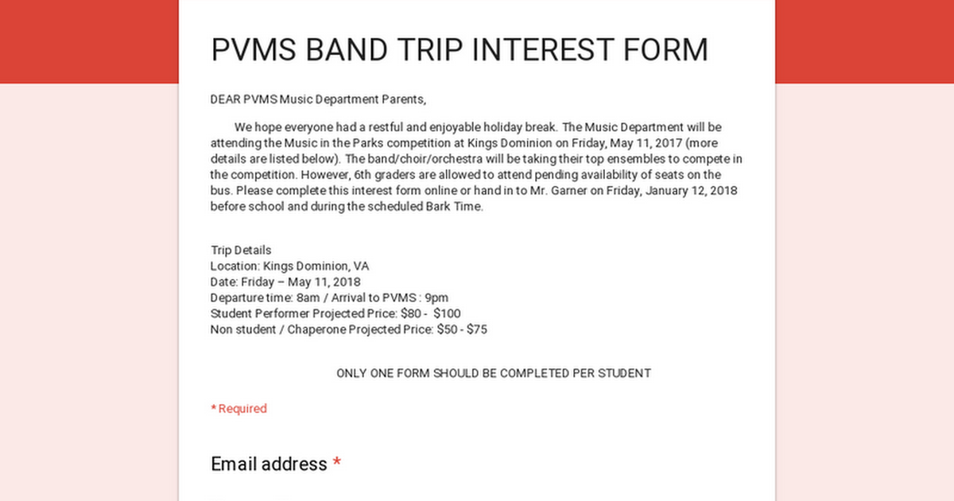

JUST A FRIENDLY REMINDER:
PARENT NIGHT AT HAMMOND HIGH SCHOOL WILL BE ON WEDNESDAY, JANUARY 8, 2018, 6:30 P.M. - 8:15 P.M.

8th Grade Panoramic Picture
The 8th graders are scheduled to take their class photo on January 18th at 9:30am in the gym. Order forms for the class photo will go home Monday prior to the photo and students will need to bring their money and completed order form at the time of the photo. If you have any questions, please contact Mrs. Salik.

Yearbook Pre-Sale Now on Until the Holiday Break!!!
It is that time of year to think about purchasing our PVMS Yearbook! Price information, purchasing directions, and order forms will be passed out to all homerooms this week. Students can either return their order and payment to their homeroom teacher or you can pay online! If you have any questions or concerns, please contact Mrs. Salik at kandyce_salik@hcpss.org.

2018 Biz Kidz Club
We are thrilled to announce the launching of our Biz Kidz Club for kidpreneurs (Ages 5-18). Membership includes participation in our upcoming Biz Kidz TV Shows, Radio Interviews, Workshops, Market Days, Shark Tank Competitions, Award Receptions, networking events and other special occasions. Club members also qualify to win education scholarships.
Please complete and submit the attached form and required fees to register. Online registration is also available at www.bizkidz.us

PVMS Market Place
Great News!! PVMS has something called Market Place. Marketplace is a place you or your student can come if you are in need of Food or Clothing should you find hard times at your doors. If you need help please contact the school and ask for Ms. Deb. Costley. Ms. Costley can also be contacted at debbie _costley @hcpss.org.

PVMS School-Based Wellness Center
The Wellness Center is a partnership between Howard County Health Department and HCPSS which provides sick visits, follow-up visits, well-child visits, chronic care management (such as asthma care), sports physicals, immunizations, health education, health screenings, and other health care services depending on the needs of the child and the family. There are two traditional School-Based Wellness Centers in Howard County (PVMS and BBES).
The Wellness Center is staffed with a pediatric nurse practitioner, medical office assistant and mental health care provider (counselor). The school Health Room continues to provide all student health services with a cluster nurse (RN) and health assistant. A sick or injured student is initially seen by the health room staff. If there is a medical concern requiring further attention, the parent is contacted and given the option to have their child seen in the Wellness Center by the pediatric nurse practitioner. Parents can always choose to take their child to their regular health provider if they prefer. Students must be enrolled to be seen in the Wellness Center. Parents can also call to make (non-emergency) appointments for their child.
Parents are always consulted prior to a student being referred or seen in the Wellness Center. The Wellness Center does not replace a student's regular health provider in the community, but gives parents options for health care during the school day.
Providing some health care services at school helps students and parents miss less time at school and work. Students can usually return to the classroom after the visit, rather than being sent home or missing another school day for an outside appointment. Students with fever, vomiting or contagious illness (such as strep throat) are still excluded from school as indicated. Although, by initiating care and treatment in the Wellness Center, that student may be able to return to school sooner. Lab tests can be done and prescriptions can be written as needed. Information from the visit is sent to the student's primary health provider in the community. Follow-up appointments can be scheduled with their regular health provider or at the Wellness Center.
The Wellness Center is additionally valuable for students who lack adequate access to health care in the community, or do not have health insurance. These families can utilize the Wellness Center for primary care needs such as yearly physicals, chronic illness management and immunizations.
The Wellness Center is available to all PVMS students, with or without health insurance. There are no co-pays, deductibles or fees. The Wellness Center is open on most school days. The Wellness Center nurse practitioner splits time between BBES and PVMS, although often can see students at either school on any day.
Please complete the attached Wellness Center enrollment forms for each of your children. If your child was enrolled previously at BBES or PVMS - they will continue to be enrolled each school year. Contact the Wellness Center if you have any questions or would like to schedule an appointment.
Annette Baldwin, CPNP-PC
Pediatric Nurse Practitioner
Howard County Health Department - Bureau of Child Health
Appointments: 301-490-1655
Bollman Bridge Elementary School Based Wellness Center; M-W-F(am): 301-490-1660
Patuxent Valley Middle School Based Wellness Center; T-Th-F(pm): 410-313-8539
Fax: 301-490-1142
abaldwin@howardcountymd.gov

Attention Parents:
The Library Media Program is desperately in need of LEGO pieces for it’s Makerspace Project Program. This program will begin during the middle of October. We will be having Monthly Contests that students in which students will compete. Students will get the opportunity to build projects out of LEGO’s in the Media Center during their Lunch Periods. Their projects will correspond with Monthly Themes which are the following:
January: Bridges or Cars
February: African American Inventions
March: Basketball Courts
April: Peep Diorama
May: Baseball Stadiums
Any donation will be accepted, but the more LEGO pieces the better. Parents may send LEGO’s in with students or parents can bring the LEGO’s to the Media Center. Please make sure that the LEGO pieces are in some type of box.

THE RONALD MCDONALD HOUSE NEEDS YOU!!!
The Ronald McDonald house in Philadelphia serves as a home-away-from-home for the entire family while their child is a patient at Children’s Hospital. Many of these children suffer from progressive and “orphan” diseases that require lengthy stays in order to minister the precise treatment. Some are patients for 9 months and longer.
The RMH charges a mere $15.00 a night for a room that includes a kitchen for the entire family. Collecting the pull-tabs from any cans is an income source for the RMH. The pull-tabs are recycled for cash which helps to finance the “House.” Your child will receive 1 Bark Buck for every 10 pull-tabs turned in. If you would like a collection jar to be at your place of employment, church or home, please contact me and I will send them home with your child.
Sincerely, Mrs. Bonnie L. Taylor Health Teacher

Greetings from the PTA!
Keep your membership and donation forms coming in! We are hoping to avoid having to do additional fundraisers by asking for straight up donations. In lieu of pizzas, candles or gift wrap, please consider sending the amount you would have spent on these directly to the PVMS PTA.

MARK YOUR CALENDAR…

January 8 Parent Information Night at Hammond High School 6:30 p.m. ~ Hammond High School
January 10 Parent Information Night at Reservoir High School 7:00 p.m. ~ Reservoir
High School
January 15 Martin Luther King Jr. Day ~ Schools and offices closed
January 25 Choir Concert 7:00 p.m. ~ Cafeteria
January 26 End of Marking Period ~ Schools close 3 hours early
January 31 Support Your Student Using Canvas 6:30 p.m. ~ Cafeteria

February 5 Report cards issued
February 16 Professional Learning Day ~ Schools closed for students
February 19 Presidents’ Day ~ Schools and offices closed

March 1 & 2 PVMS Drama Production - Show 6:00 p.m. ~ Cafeteria
March 5 & 6 Middle School Orchestra Assessments 2:00 p.m. ~ R.H.S.
March 7 Middle School Orchestra Adjudication 2:00 p.m. ~ R.H.S.
March 7 Interim Progress reports issued
March 26 County Debate 9:00 a.m. ~ Hopkins
APL
March 30 Schools and offices closed

