February 9, 2018

Staff Diversity Celebration Lunch
Dear Parents and Guardians,
Please help us put together a great lunch for teachers and staff at PVMS! We are celebrating the diversity of our student and staff population. Our staff would love to sample some foods from your family tradition and culture! Please donate a food or volunteer to show appreciation for our hardworking staff. Thank you! PVMS PTA
http://www.signupgenius.com/go/10c0d4ea8a629a31-pvms3
Contact Debbie_Costley@hcpss.org or ledwards2000@verizon.net with questions.

National Junior Honor Society Update:
NJHS Induction: Our students that are new to NJHS will be Inducted on Wednesday, February 21st at 6:00 PM. Students should arrive to school no later than 5:40 PM the evening of the Induction, and we anticipate the ceremony and reception will be done by 7:30pm. Inductees should dress nicely in a combination of black and white. The Volunteer and Kudos Squares forms deadline have been extended to February 7nd. Please consider volunteering your time for set-up/ clean-up and food, drinks, paper goods, or flowers for the event. The Kudos squares are not only a fundraiser, but a great way to celebrate and recognize your child’s Induction. Please email Ms. Bickerton if you did not receive a form.

Wellness Center at PVMS
If you have not yet completed the forms for the Wellness Center... visit the PVMS website or contact the Wellness Center directly to obtain the enrollment packet.
The Wellness Center services are available to all students without charge. Parents can make appointments directly, or if a student comes to the health room due to illness or injury, parents will be contacted to discuss if they would like their child seen that day by the nurse practitioner. The Wellness Center does not replace a student's regular health provider in the community; rather, it is an option for health care during the school day. Providing some health care services at school helps students miss less school time. Contact the Wellness Center if you have any questions or would like to schedule an appointment.
Annette Baldwin, CPNP-PC
Pediatric Nurse Practitioner - Howard County Health Department - Bureau of Child Health
Appointments: 301-490-1655
BBES Wellness Center; M-W-F(am): 301-490-1660
PVMS Wellness Center; T-Th-F(pm): 410-313-853

ATTENTION: PARENTS OF 6TH GRADERS
**IMPORTANT INFORMATION FOR THE 2018-2019 SCHOOL YEAR REGARDING IMMUNIZATION REQUIREMENTS FOR 7TH GRADE
FROM THE HEALTH ROOM:
All students who will be entering Grade 7 in the fall 2018 are required by the state of Maryland to have proof of 1 dose of the Tdap vaccine and 1 dose of the Meningococcal vaccine (MCV4) by the first day of the 2018-2019 school year. If we DO NOT receive proof of immunization, your child will be excluded from school. Many students may have already received these immunizations, but the Health Room may not have the updated immunization record. Please contact your child’s doctor and send/fax in an updated copy of your child’s immunizations to the Health Room. Our fax number is (301) 490-3780. Students receiving immunizations over the summer can either email the scanned copy to dee_goldstein@hcpss.org or drop the form off in the front office.
If you have further questions, please call PVMS on (410) 880-5840 and ask for the Health Room.

Black History Month ~ February 2018
Featured Activities include:
Guest Speakers, Dress for Success Fridays, Music highlights, Introduction to Genealogy, Diversity Luncheon, Contests and more!
For Details - See Ms Deb!
We are looking for speakers, volunteers, musicians, chefs, authors, moms, dads, and anyone who can compliment our community, in order to promote our theme of the Diversity Dream!
This is your chance to share your culture!
410- 880-5840 or costleydebbie@yahoo.com

Yearbook Sale Now Until the April 1st!!!
It is that time of year to think about purchasing our PVMS Yearbook! Price information, purchasing directions, and order forms are available in all homerooms. Students can either return their order and payment to their homeroom teacher or you can pay online! If you have any questions or concerns, please contact Mrs. Salik at kandyce_salik@hcpss.org.

Music Department Notes
Dear PVMS Music Department Parents,
As we prepare for upcoming Spring competition /trip to Kings Dominion on May 11, 2018, we need for all band / choir/ orchestra parents to complete the Music Department Spring Trip Interest Form. This form can be completed online, and the link is listed below. * Please note, only complete one form per child. If you have a child in band and another child in orchestra, you would need to complete 2 online forms. Thanks so much for your time.

PVMS MUSIC TRIP INTEREST FORM - https://docs.google.com/forms/d/e/1FAIpQLSffmKpvf2OYOk-5-lgVy6CVB9WMfkPhUa4hVw0RZKMMHrVMxA/viewform?usp=sf_link
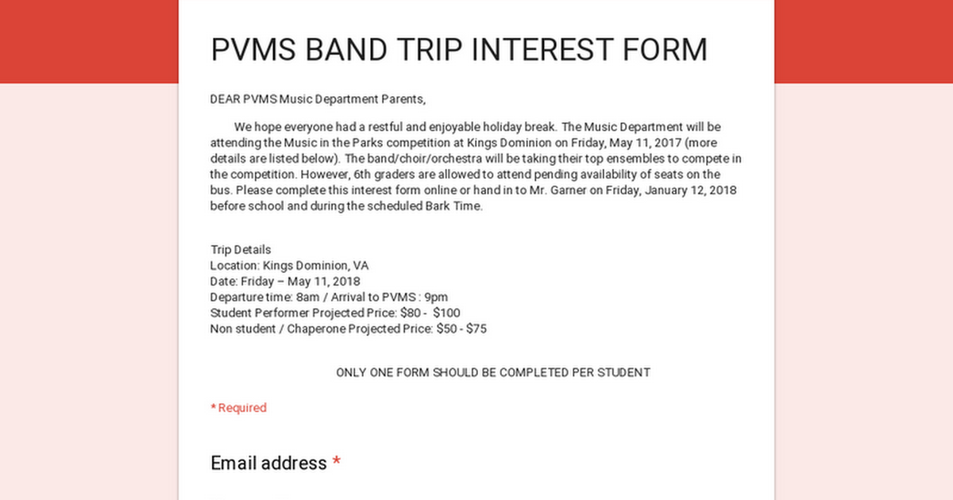

2018 Biz Kidz Club
We are thrilled to announce the launching of our Biz Kidz Club for kidpreneurs (Ages 5-18). Membership includes participation in our upcoming Biz Kidz TV Shows, Radio Interviews, Workshops, Market Days, Shark Tank Competitions, Award Receptions, networking events and other special occasions. Club members also qualify to win education scholarships.
Please complete and submit the attached form and required fees to register. Online registration is also available at www.bizkidz.us

PVMS Market Place
Great News!! PVMS has something called Market Place. Marketplace is a place you or your student can come if you are in need of Food or Clothing should you find hard times at your doors. If you need help please contact the school and ask for Ms. Deb. Costley. Ms. Costley can also be contacted at debbie _costley @hcpss.org.

Attention Parents:
The Library Media Program is desperately in need of LEGO pieces for it’s Makerspace Project Program. This program will begin during the middle of October. We will be having Monthly Contests that students in which students will compete. Students will get the opportunity to build projects out of LEGO’s in the Media Center during their Lunch Periods. Their projects will correspond with Monthly Themes which are the following:
February: African American Inventions
March: Basketball Courts
April: Peep Diorama
May: Baseball Stadiums
Any donation will be accepted, but the more LEGO pieces the better. Parents may send LEGO’s in with students or parents can bring the LEGO’s to the Media Center. Please make sure that the LEGO pieces are in some type of box.

THE RONALD MCDONALD HOUSE NEEDS YOU!!!
The Ronald McDonald house in Philadelphia serves as a home-away-from-home for the entire family while their child is a patient at Children’s Hospital. Many of these children suffer from progressive and “orphan” diseases that require lengthy stays in order to minister the precise treatment. Some are patients for 9 months and longer.
The RMH charges a mere $15.00 a night for a room that includes a kitchen for the entire family. Collecting the pull-tabs from any cans is an income source for the RMH. The pull-tabs are recycled for cash which helps to finance the “House.” Your child will receive 1 Bark Buck for every 10 pull-tabs turned in. If you would like a collection jar to be at your place of employment, church or home, please contact me and I will send them home with your child.
Sincerely, Mrs. Bonnie L. Taylor Health Teacher

Greetings from the PTA!
Keep your membership and donation forms coming in! We are hoping to avoid having to do additional fundraisers by asking for straight up donations. In lieu of pizzas, candles or gift wrap, please consider sending the amount you would have spent on these directly to the PVMS PTA.

CAMP IMPROV- Summer comedy camp for middle school students!
Session 1: July 9-13, Session 2: July 16-20
Director: Kathryn Carlsen, Centennial HS Theatre
Website: campimprov.org
This camp is all about the joy of jumping in and finding the funny. Listening, saying “yes, and,” collaboration and flexibility are key. Though there is a focus on the basics, students with prior improv experience will find an opportunity to strengthen their basic comedy muscles.
Time: Monday- Friday, 9am-12pm
Students will work on teamwork, trust, support and artistic collaboration through improv exercises and short form games, like the ones played on Whose Line Is It Anyways? Students will perform a show at the end of the week featuring the games that they learned.
Location: Camp Improv takes place at Centennial High School on the stage and in theatre room.
Cost: $195 includes a Camp Improv shirt
Performance: Students will perform on the Friday of the camp week at 7pm. All tickets to the show are complimentary!
Registration Due: June 1st. Returned check fee is $25.
Questions? Email Kathryn Carlsen at kcarlsen@hcpss.org
Camp Improv is supported by the Centennial High School Boosters.
Visit campimprov.org for information and registration.

MARK YOUR CALENDAR…

February 16 Professional Learning Day ~ Schools closed for students
February 19 Presidents’ Day ~ Schools and offices closed
February 21 NJHS Induction Ceremony 6:00 p.m. ~ Gym

March 1 & 2 PVMS Drama Production - Show 6:00 p.m. ~ Cafeteria
March 5 & 6 Middle School Orchestra Assessments 2:00 p.m. ~ R.H.S.
March 7 Middle School Orchestra Adjudication 2:00 p.m. ~ R.H.S.
March 7 Interim Progress reports issued
March 26 County Debate 9:00 a.m. ~ Hopkins
APL
March 30 Schools and offices closed

April 2 - 6 Spring Break ~ Schools closed for students
April 12 International Night/Spring Fling 5:00 p.m. ~ Cafeteria
April 13 End of Marking Period ~ Schools close 3 hours early
April 23 Report cards issued

