Important Dates

February 19 Presidents’ Day ~ Schools and offices closed
February 21 NJHS Induction Ceremony 6:00 p.m. ~ Gym
February 23 SPIRIT DAY – Dress in your Native Clothes for
Black History Month

March 1 & 2 PVMS Drama Production - Show 6:00 p.m. ~ Cafeteria
March 5 & 6 Middle School Orchestra Assessments (7 & 8 Grade) 2:00 p.m. ~ R.H.S.
March 7 Middle School Orchestra Adjudication (6th Grade) 2:00 p.m. ~ R.H.S.
March 7 Interim Progress reports issued
March 20 Middle School Band Assessments (7 & 8 Grades) 4:00 p.m. ~ A.H.S.
March 21 Middle School Band Adjudication (6th Grade) 6:15 p.m. ~ A.H.S.
March 26 County Debate 9:00 a.m. ~ Hopkins
APL
March 29 8th Grade to see Romeo & Juliet 9:30 a.m. ~ Balt. City
March 30 Schools and offices closed

April 2 - 3 Spring Break ~ Schools closed for students
April 12 International Night/Spring Fling 5:00 p.m. ~ Cafeteria
April 12 Choral Adjudication (6th Grade) 11:00 a.m. ~ L.R.H.S.
April 13 End of Quarter Bulldog Day Celebration hosted by PBIS
End of Marking Period ~ Schools close 3 hours early
April 20 8th Grade Field Trip to Days End Horse Farm 10:00 a.m. ~ Days End
April 23 Report cards issued
April 26-27 Environmental Film Festival Field Trip 9:00 a.m. ~ Silver Spring, MD
April 28 PVMS 5K 8:30 a.m. ~ Cafeteria

8th Period
8th Period Programs are running Tuesdays, Wednesdays, and Thursdays from 2:30pm-4:15pm. Buses leave school promptly at 4:20pm. Students riding the buses can be expected home by 5pm. The following programs are currently running. If you would like your child to participate in a program, please reach out to Maggie Bosse at Margaret_Bosse@hcpss.org

Tuesdays | Wednesdays | Thursdays
Reading/HW & Organization | Reading/HW & Organization | Math 8 support
Creative Writing | NJHS (alternate weeks) | Running Club
Chess Academy | Running Club | Archery
Be The Change | Latin Dance | International Club (alternate weeks)
Archery | Student Council (alternate weeks)
Algebra I Prep | Orchestra Practice
Dungeons & Dragons

The following programs ended and are no longer running: Boys Coding Club, codeHER, and Thursday Reading/Organization.

Greetings from the PTA!
Keep your membership and donation forms coming in! We are hoping to avoid having to do additional fundraisers by asking for straight up donations. In lieu of pizzas, candles or gift wrap, please consider sending the amount you would have spent on these directly to the PVMS PTA.

Reservoir High School Summer Booster Camp
Come out to sports camp the week of July 16th at Reservoir High School with Howard county teachers Phil Ranker (PE), Tom Dougherty (Math) and Erika Lupo (PE). The camp is open to Rising 1st-9th graders and features many different sports and activities every day. If your child likes PE, they will love camp. Campers are split into age and ability groups to ensure that everyone has a great and productive time. For more information, please visit http://rankerssportscamp.weebly.com or email phillip_ranker@hcpss.org for questions!

Wellness Center Updates
If you have not yet completed the forms for the Wellness Center... visit the PVMS website or contact the Wellness Center directly to obtain the enrollment packet.
The Wellness Center services are available to all students without charge. Parents can make appointments directly, or if a student comes to the health room due to illness or injury, parents will be contacted to discuss if they would like their child seen that day by the nurse practitioner. The Wellness Center does not replace a student's regular health provider in the community; rather, it is an option for health care during the school day. Providing some health care services at school helps students miss less school time. Contact the Wellness Center if you have any questions or would like to schedule an appointment.
Annette Baldwin, CPNP-PC
Pediatric Nurse Practitioner - Howard County Health Department - Bureau of Child Health
Appointments: 301-490-1655
BBES Wellness Center; M-W-F(am): 301-490-1660
PVMS Wellness Center; T-Th-F(pm): 410-313-8530

ATTENTION: PARENTS OF 6TH GRADERS
**IMPORTANT INFORMATION FOR THE 2018-2019 SCHOOL YEAR REGARDING IMMUNIZATION REQUIREMENTS FOR 7TH GRADE FROM THE HEALTH ROOM:

All students who will be entering Grade 7 in the fall 2018 are required by the state of Maryland to have proof of 1 dose of the Tdap vaccine and 1 dose of the Meningococcal vaccine (MCV4) by the first day of the 2018-2019 school year. If we DO NOT receive proof of immunization, your child will be excluded from school. Many students may have already received these immunizations, but the Health Room may not have the updated immunization record. Please contact your child’s doctor and send/fax in an updated copy of your child’s immunizations to the Health Room. Our fax number is (301) 490-3780. Students receiving immunizations over the summer can either email the scanned copy to dee_goldstein@hcpss.org or drop the form off in the front office.
If you have further questions, please call PVMS at (410) 880-5840 and ask for the Health Room.

Military Information Night
March 7, 2018 P 6:30-9 pm P Oakland Mills High School HCPSS students in grades 7-12 who are interested in collegiate and U.S. military programs and their parents are invited. The following groups will offer information about their programs:
* Representatives from five U.S. military academies
* College ROTC programs
* Members of the Howard County JROTC programs from Atholton, Howard, and Oakland Mills high schools
* Military enlistment recruiters
* Representatives from local congressional offices and the U.S. military academies also will provide information about academy nomination and application processes.
For more information, contact Philip Vangeli at 410-313-7400 or pvangeli@hcpss.org.

Teacher Appreciation Lunch
What’s your specialty? Italian style meatballs? Swedish meatballs? Corned beef and cabbage? Southern style Mac n cheese? German potato salad? Curry chicken? Cornbread? Sweet potato pie? Please consider sending in any of your favorite foods for our hardworking teachers and staff on February 28. Please see our Sign-Up-Genius for details. Thank you!!!
http://www.signupgenius.com/go/10c0d4ea8a629a31-pvms3

National Junior Honor Society Update
NJHS Induction: Our students that are new to NJHS will be Inducted on Wednesday, February 21st at 6:00 PM. Students should arrive to school no later than 5:40 PM the evening of the Induction, and we anticipate the ceremony and reception will be done by 7:30pm. Inductees should dress nicely in a combination of black and white. The Volunteer and Kudos Squares forms deadline have been extended to February 7nd. Please consider volunteering your time for set-up/ clean-up and food, drinks, paper goods, or flowers for the event. The Kudos squares are not only a fundraiser, but a great way to celebrate and recognize your child’s Induction. Please email Ms. Bickerton if you did not receive a form.

Black History Month
Featured Activities include: Guest Speakers, Dress for Success Fridays, Music highlights, Introduction to Genealogy, Diversity Luncheon, Contests and more!
For Details contact Deb Costley at 410-880-5840.

Music Department Notes
Dear PVMS Music Department Parents,
As we prepare for upcoming Spring competition /trip to Kings Dominion on May 11, 2018, we need for all band / choir/ orchestra parents to complete the Music Department Spring Trip Interest Form. This form can be completed online, and the link is listed below. * Please note, only complete one form per child. If you have a child in band and another child in orchestra, you would need to complete 2 online forms. Thanks so much for your time.

PVMS MUSIC TRIP INTEREST FORM - https://docs.google.com/forms/d/e/1FAIpQLSffmKpvf2OYOk-5-lgVy6CVB9WMfkPhUa4hVw0RZKMMHrVMxA/viewform?usp=sf_link
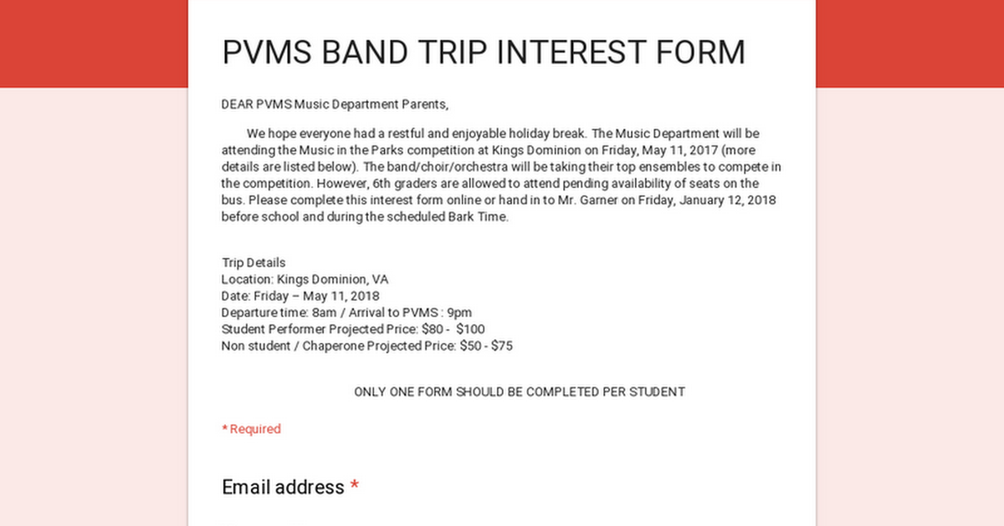

2018 Biz Kidz Club
We are thrilled to announce the launching of our Biz Kidz Club for kidpreneurs (Ages 5-18). Membership includes participation in our upcoming Biz Kidz TV Shows, Radio Interviews, Workshops, Market Days, Shark Tank Competitions, Award Receptions, networking events and other special occasions. Club members also qualify to win education scholarships. Please complete and submit the attached form and required fees to register. Online registration is also available at www.bizkidz.us

PVMS Market Place
PVMS Market Place is fully stocked with clothing items for all ages. If you are a family or know a family in need, please reach out to PVMS at 410-880-5840 and ask for Deb Costley.

Attention Parents:
The Library Media Program is desperately in need of LEGO pieces for it’s Makerspace Project Program. This program will begin during the middle of October. We will be having Monthly Contests that students in which students will compete. Students will get the opportunity to build projects out of LEGO’s in the Media Center during their Lunch Periods. Their projects will correspond with Monthly Themes which are the following:
February: African American Inventions
March: Basketball Courts
April: Peep Diorama
May: Baseball Stadiums
Any donation will be accepted, but the more LEGO pieces the better. Parents may send LEGO’s in with students or parents can bring the LEGO’s to the Media Center. Please make sure that the LEGO pieces are in some type of box.

THE RONALD MCDONALD HOUSE NEEDS YOU!!!
The Ronald McDonald house in Philadelphia serves as a home-away-from-home for the entire family while their child is a patient at Children’s Hospital. Many of these children suffer from progressive and “orphan” diseases that require lengthy stays in order to minister the precise treatment. Some are patients for 9 months and longer.
The RMH charges a mere $15.00 a night for a room that includes a kitchen for the entire family. Collecting the pull-tabs from any cans is an income source for the RMH. The pull-tabs are recycled for cash which helps to finance the “House.” Your child will receive 1 Bark Buck for every 10 pull-tabs turned in. If you would like a collection jar to be at your place of employment, church or home, please contact me and I will send them home with your child.
Sincerely, Mrs. Bonnie L. Taylor Health Teacher

CAMP IMPROV- Summer comedy camp for middle school students!
This camp is all about the joy of jumping in and finding the funny. Listening, saying “yes, and,” collaboration and flexibility are key. Though there is a focus on the basics, students with prior improv experience will find an opportunity to strengthen their basic comedy muscles. Students will work on teamwork, trust, support and artistic collaboration through improv exercises and short form games, like the ones played on Whose Line Is It Anyways? Students will perform a show at the end of the week featuring the games that they learned.

Session 1: July 9-13, Session 2: July 16-20
Time: Monday- Friday, 9am-12pm
Director: Kathryn Carlsen, Centennial HS Theatre
Website: campimprov.org
Location: Camp Improv takes place at Centennial High School on the stage and in theatre room.
Cost: $195 includes a Camp Improv shirt
Performance: Students will perform on the Friday of the camp week at 7pm. All tickets to the show are complimentary!
Registration Due: June 1st. Returned check fee is $25.
Questions? Email Kathryn Carlsen at kcarlsen@hcpss.org
Camp Improv is supported by the Centennial High School Boosters.
Visit campimprov.org for information and registration.

